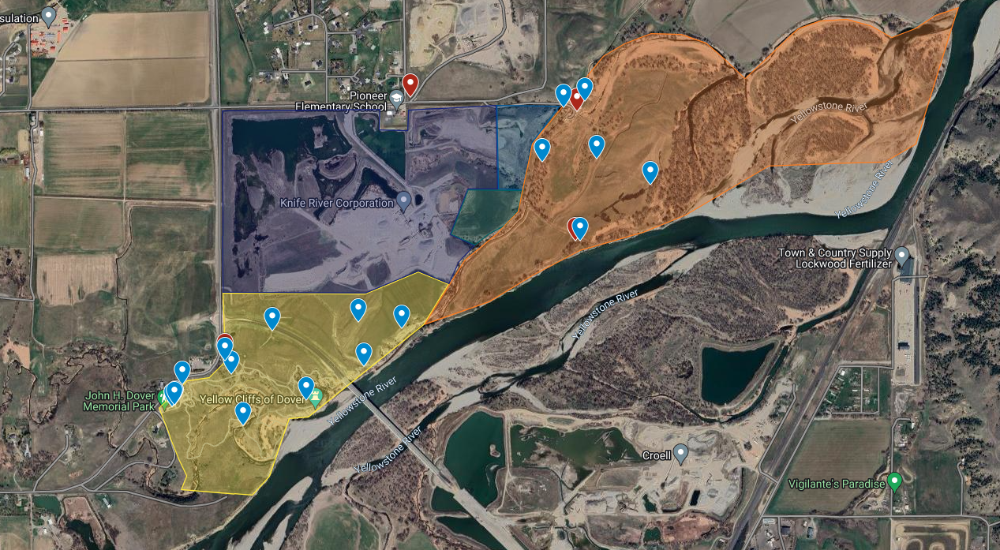
HQ, entrances, bathrooms
Area 1 Blue Zone Headquarters

 Bathroom

Area 1 Projects
Staining bridge deck-Double suspension bridge. Stain wooden decking with brown-tinted deck stain. Provided by YRPA(Need brushes, buckets, stain, paint thinner, and rubber gloves.) Also stain TWO small flat wooden bridges between parking lot and double suspension bridge.

Staining bridge deck-Single suspension bridge. Stain wooden decking with brown-tinted deck stain. Provided by YRPA(Need brushes, buckets, stain, paint thinner, rubber gloves.)

Fence Removal-Remove posts and roll up wire fencing along Five Mile Road where interfering with ditch. Clippers welcomed.

Limestone on trails-Meet in parking lot, take a wheelbarrow and shovels and walk trails to lay down new limestone where fabric is exposed on trails. In addition to parking lot, there are two piles of limestone in the field.

Landscaping work-Help plant shrubs and wildflowers near Dover Activity Center.

Thistle and Mullein-Dig up mullein plants and chop off flower heads of scotch thistle along trails. Take shovels, clippers, and trash bags. Mullein can be discarded away from trails, thistle heads need to be bagged and trashed. Thistle stalks/leaves can be discarded away from trails

Concrete Pads-Help frame/pour concrete for bike rack and bicycle repair station

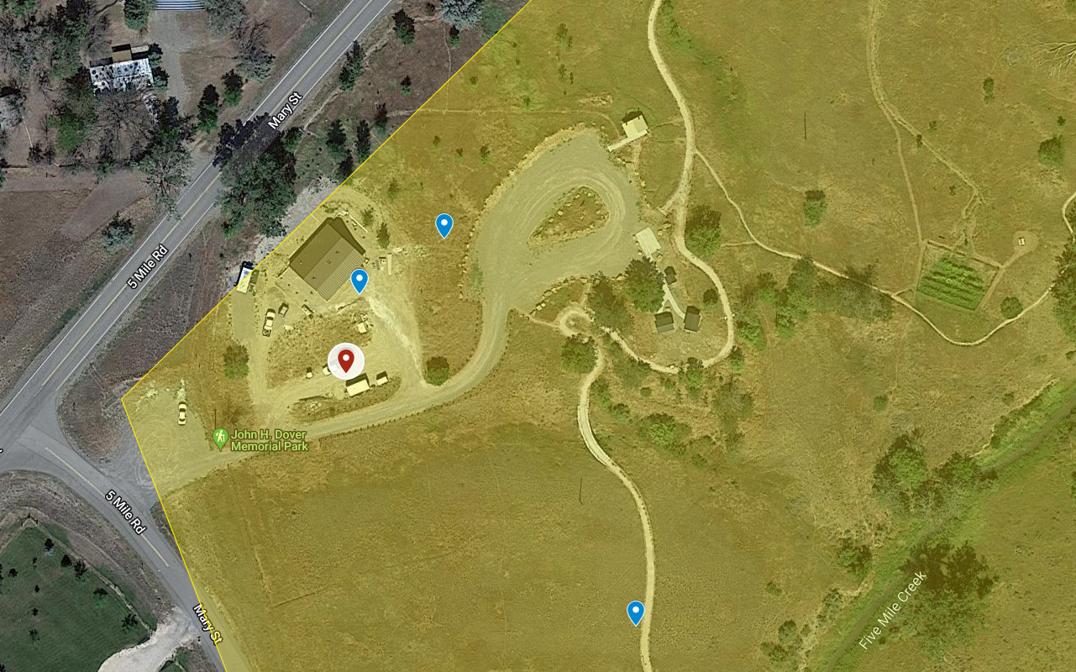
Area 1 Blue Zone Flag color is Blue
Area 1 Blue Zone headquarters with blue Live United flag
Education Building/ bathroom
Bathroom
Parking
Parking
Area 1 Blue Zone entrance
30 parking spots 2 bathrooms, 2 picnic shelters

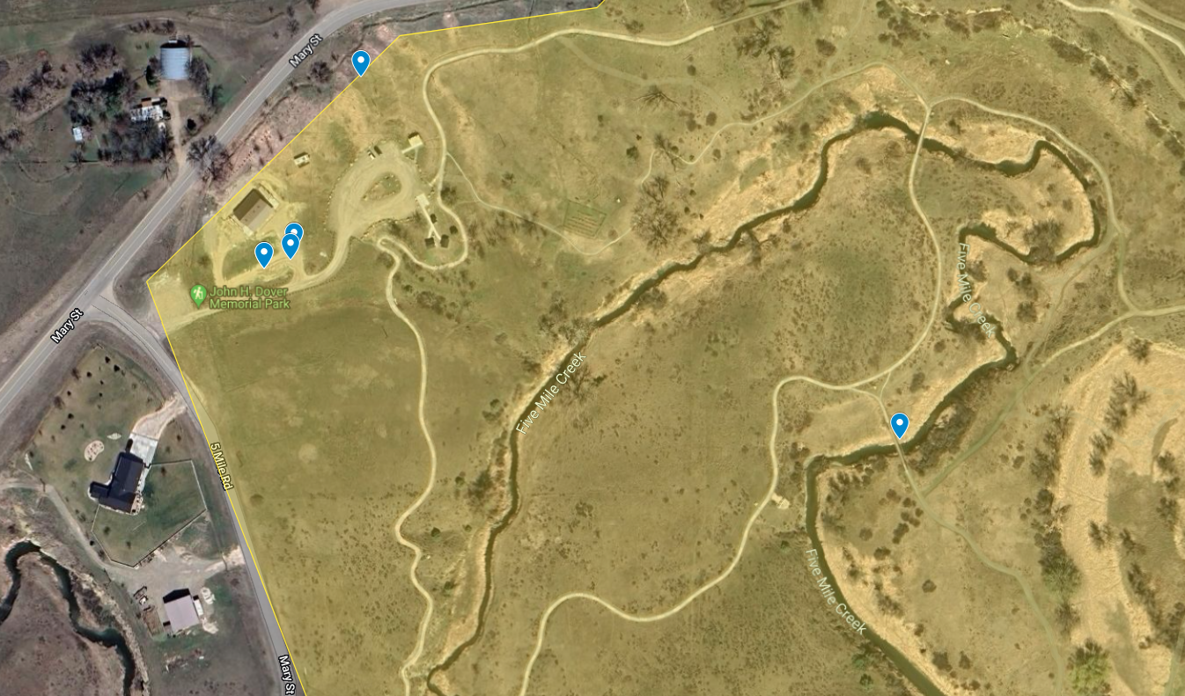
Staining Bridge Deck

Fence Removal
Bathroom
Staining Bridge Deck
Limestone on Trails
Thistle and Mullein
Landscape Work
Concrete Pads
Parking
Parking
Area 1 Blue Zone Headquarters with Blue Live United Flag

